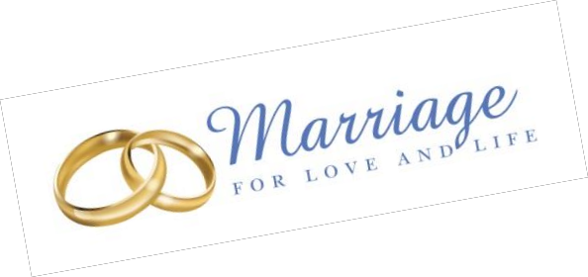Archdiocese of Baltimore marriagemattersbalt.org

Pre-Wedding Checklist

Announce your engagement. Congratulations!
Contact your parish church (usually the bride's, but it may be the groom's parish) and make an appointment to meet with the Priest or Deacon (or his representative) for the Pre-nuptial Investigation. This is not the same thing as your "marriage preparation course".
Catholic weddings are celebrated in a church as a sign of the sacrament.
For the meeting, you will need to bring a recently-issued (dated within six months before the wedding) copy of your baptism certificate, with notations. To request copy of your baptism record, contact the church where you were baptized. If one party is baptized in another Christian tradition, provide a letter attesting to the baptism.
At the Initial Meeting, the priest or deacon (or his representative) will interview you and complete the Pre- nuptial Investigation to determine your freedom to marry.
Reserve a wedding date on the parish calendar (Note: In the case where one or both were previously
married (even outside the Catholic Church), the decree(s) of annulment must be received before a date for your wedding can be set.)
Celebrating your wedding at a church other than your parish church? The Pre-Nuptial investigation is still
normally done at your own parish. Your priest or deacon will obtain permission for you to be married in another church.
Schedule a rehearsal time with the church
Register for a Marriage Preparation Course.
Make arrangements for the reception, honeymoon, clothing and travel.
Invite friends and relatives to serve as wedding attendants, readers for Scripture and prayers, ushers, greeters, or altar servers.
Investigate Natural Family Planning methods. Complete your Marriage Preparation course.
Meet with your priest/deacon again (number of meetings will vary). Select Scripture readings and other prayers for your wedding.
Make arrangements with the church musician.
Secure marriage license from city or county where the marriage is to take place. There is a waiting period of three working days between application and receipt of license within the State of Maryland. Requirements for other places will vary. Give the license to the clergyman before the wedding.
Make time for personal prayer and reflection throughout this preparation time. The Sacraments of
Reconciliation and Eucharist are valuable sources of grace and healing. Rehearse at the church.
Go to church, and marry your beloved.
Live the Sacrament of Matrimony.

